|  |
| --- |
| **BATCH AND ROLL NO:** |
| **EXPERIMENT NO.1** |
| **TITLE:** Install and Configure Eclipse / Android Studio on Linux/windows platform. |
| **DATE OF PERFORMANCE:** |
| **DATE OF SUBMISSION:** |

**Title:** Install and Configure Eclipse / Android Studio on Linux/windows platform.

**Requirements:**

1 Android studio

2. Java SDK

**Theory:**

Android Studio stands out as a premier choice for Android app development, offering a robust set of features and integrated tools to create polished and professional Android applications.

Key features include a comprehensive Android emulator, sophisticated testing tools, and a seamless development environment. Additionally, the program boasts an intelligent code editor that not only assists in writing code but also provides advanced suggestions for improved efficiency.

For those new to Android development, the initial setup of Android Studio may pose some challenges due to various configuration steps. In this guide, we will walk you through the process of installing Android Studio on a Windows platform and demonstrate how to create a basic sample application. Whether you're a novice developer or an experienced coder, our step-by-step instructions aim to simplify the setup process and get you started on your Android app development journey.

## Java JDK

* Before installing Android Studio, you first need to install the Java JDK and set up the Java environment to start working on it.
* The Java Development Kit (JDK) is a required development package for creating Java-based applications. Additionally, it also includes tools for developers for testing Java-coded applications.

**Follow these steps to get the latest version of Java JDK for Windows and set it up:**

1. Go to the official [**Oracle Java Downloads**](https://www.oracle.com/java/technologies/downloads/) page.
2. Choose the most recent version of Java JDK and download the**x64 MSI Installer** under the**Windows** tab.

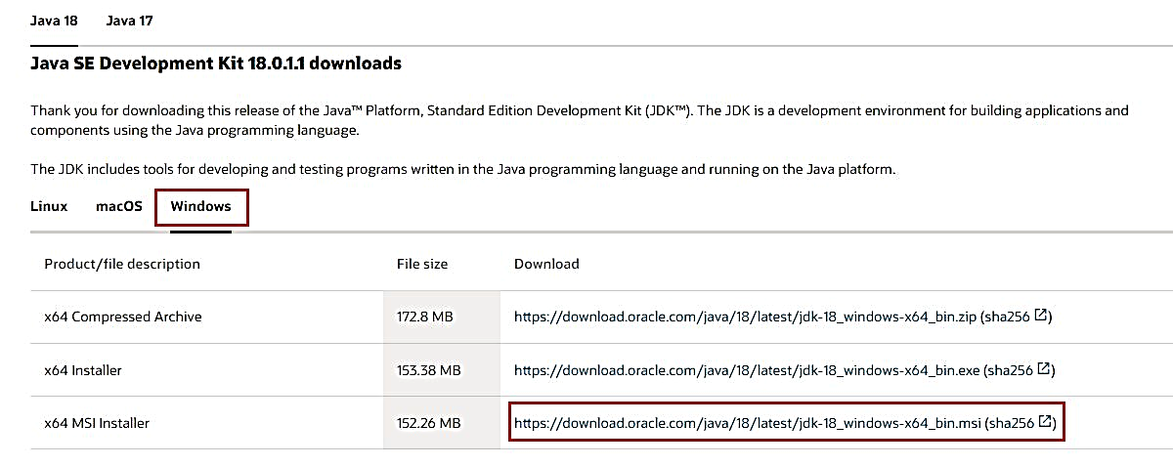

1. Open the file you've just downloaded from the **Downloads** folder.
2. Follow the on-screen instructions to install the latest Java JDK.

Once JDK installed successfully, next step is to set up a Java environment so that Android Studio can easily find the location of Java on desktop.

### **Steps for Setting Up the Java Environment**

1. Open Windows search and type "Edit environment variables."
2. Hit the **Enter** key to open the **Environment Variables** window.
3. Now, under the **System variables** section, click**Path > Edit > New**

1. Copy the path of the folder where the JDK binaries are installed. For example, in our case, the path is **C:\Program Files\Java\jdk-18.0.1.1\bin.**
2. Switch to the Environment variables window and paste the path you've copied and save the changes.
3. Next, under the **User Variables** section, click **New**.
4. Add **PATH_HOME** in the variable name box and **C:\Program Files\Java\jdk-18.0.1.1**in the variable value box.
5. Finally, save the changes by clicking **OK**.

NOTE: [In general, you do not need to reconfigure any environment variables if you have already done so. But if it's your first time, setting the variables will help you reduce Java-based errors during compilation.]

## Steps to Install Android Studio on Windows

1. Visit the [**Android Developers**](https://developer.android.com/studio) website and click on **Download Android Studio**.

1. Now, open the downloaded file to install Android Studio.
2. Click **Next** to continue installing Android Studio.

1. Further, click **Install**and wait while Android Studio is being installed on your PC.
2. Once done, click **Finish** to close the installer and start Android Studio.
3. Android Studio will now ask you to import settings. Click **OK** to continue to set up Android Studio.

### **The System Requirements for Android Studio on Windows**

Your PC must meet the following requirements to run Android Studio efficiently:

* 64-bit Microsoft Windows OS 8/10/11.
* 1280 x 800 minimum screen resolution.
* x86_64 CPU architecture; 2nd generation Intel Core or newer; or AMD CPU with Hypervisor support.
* 8GB of RAM or more.
* 12GB of available disc space is required (IDE + Android SDK + Android Emulator).

#### OUTPUT:

#### CONCLUSION:

#### ………………………………………………………………………………………………………………………………………………………………………………………………………………………………………………………………………………………